**Assignment – 1**

* **Install Power BI Desktop and share the final screenshot of the report view page which appears when power desktop starts.**

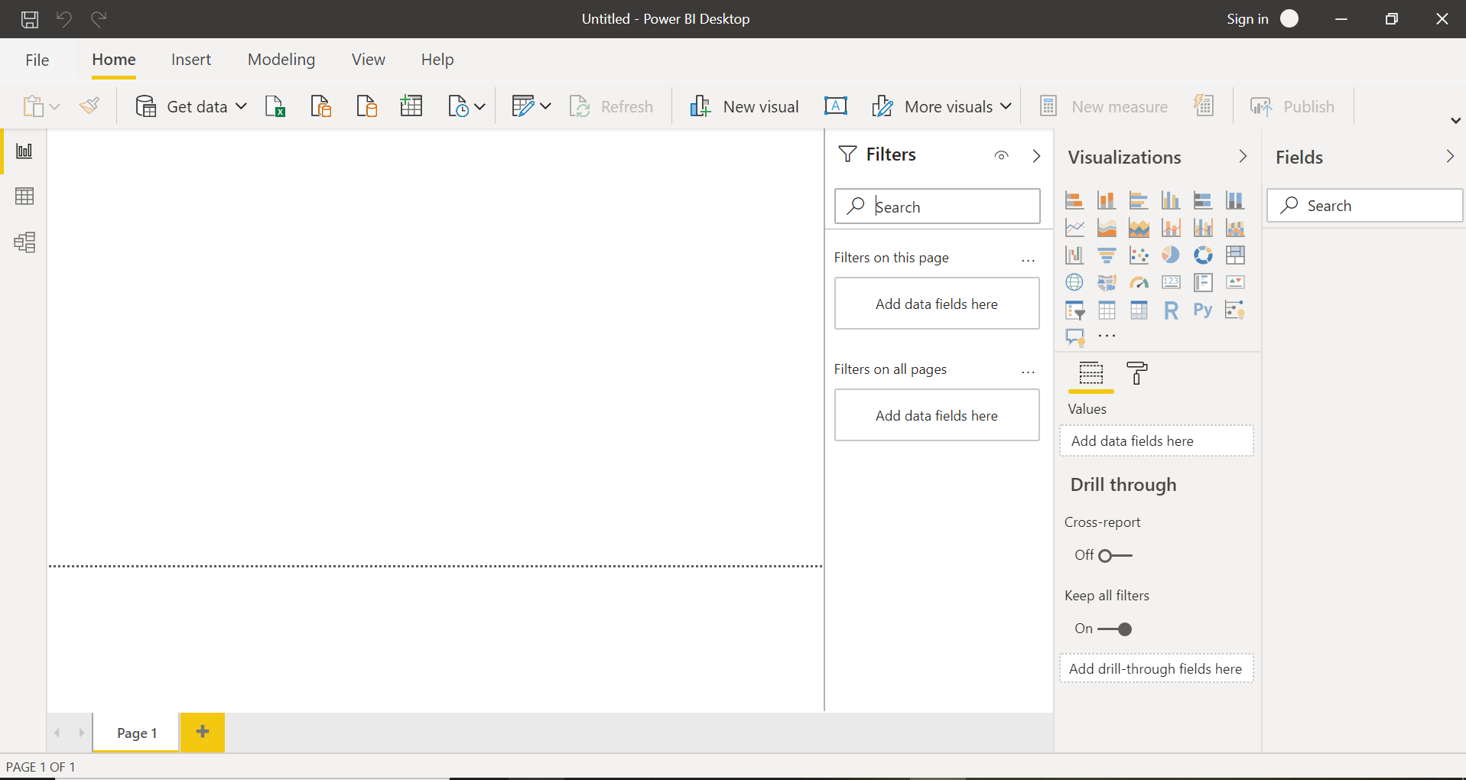

* **Prepare a document and with the following screenshot**

1. Report View



1. Data View

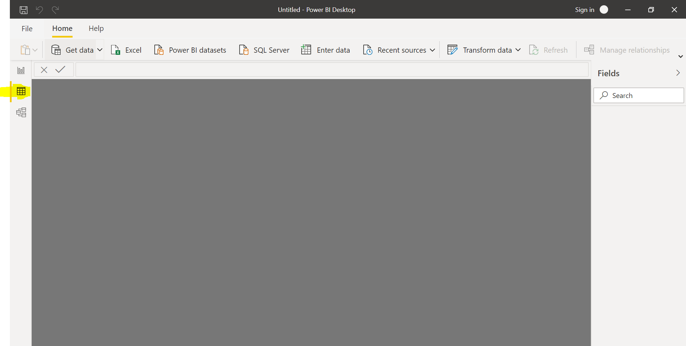

1. Model View

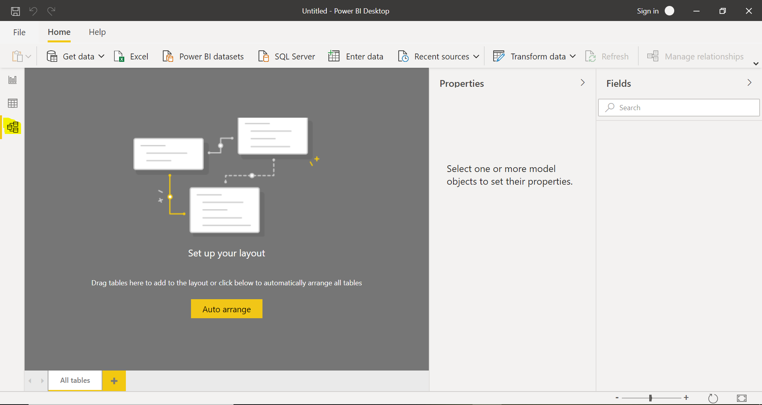

1. Power Query Editor

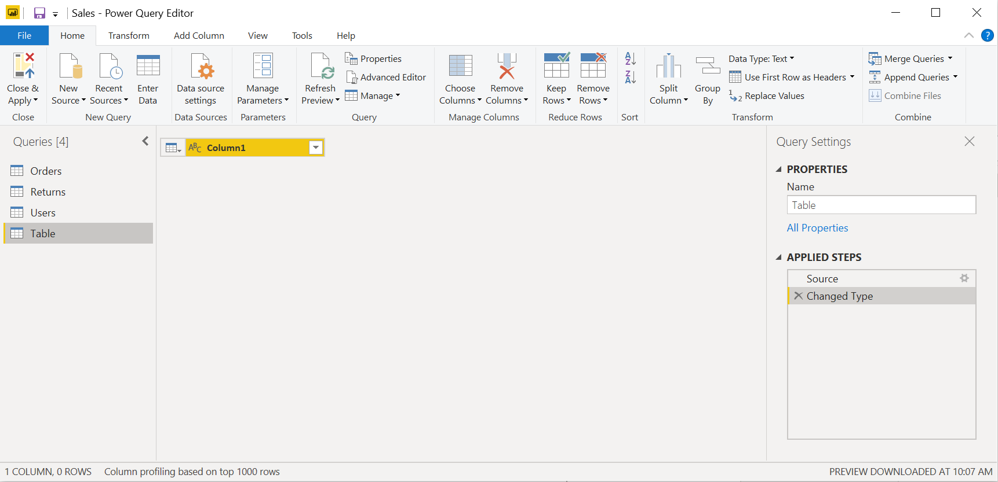

1. Advance Editor

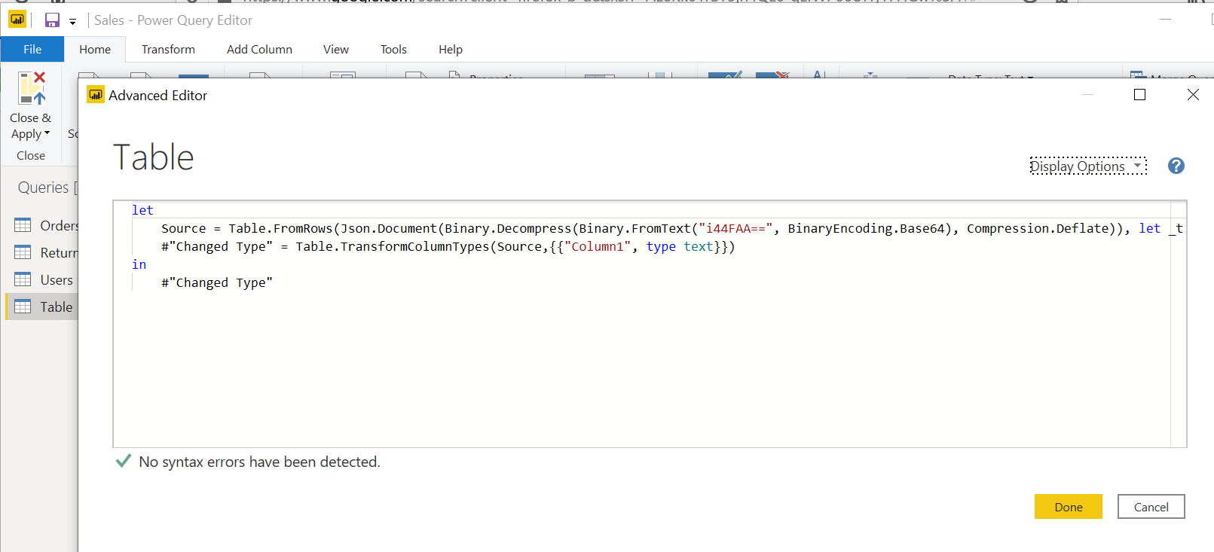

* **Prepare a document with details of the following along with their price**
* Power BI Desktop

Power BI desktop comes with 60 days free trial

* Power BI Pro

$9.99 dollars per month per user

* Power BI Premium

$4,995 - Monthly price per dedicated cloud compute and storage resource with annual subscription